

ENVIRO365

JUNIOR BUSINESS ANALYST ASSESSMENT

**Instructions**

Complete All the questions on the assessment for the below scenarios.

Please submit your assessment response within 5 working days of receiving the assessment.

# Scenario 1: DBS Investment

You are a Business Analyst who is meeting up with various Salesperson to understand their current processes, assess and propose improvements.

Below are snippets of the conversation you had with a Sales Manager, John.

John is a sales Manager selling variety of equity and products to a segment of clients**.**

“Sometimes, I get referrals from colleagues from other parts of the business. But sometimes, the clients will approach me directly too.”

“It depends on the clients. Some knows what they want and will confirm an order quickly. Others might be new to the market and will call me a few times on the products and prices. It’s quite troublesome because prices for simple products are available in the system but for the more complex ones, I have to contact the Pricing Manager.

Sometimes I can’t get him because he’s talking to other sales manager and when the client gets impatient waiting for the price, I might lose the deal.”

“Concurrently, I have to reply to clients’ pricing enquiries on our chat messaging system and emails so it’s quite tedious.”

“Once the client has confirmed an order, we will need to send them a term sheet document on the same day. The document will contain important details about the deal. Some clients may acknowledge but it’s not mandatory. We need to archive these documents for audit purposes.”

“For confirmed orders, our operations department will compare the document order details against the order details captured in the company’s system. If there is any discrepancy, the operations department will speak to Sales to determine if the document or the order in the system is incorrect. If the document is incorrect, I will need to re-generate the document to the client and operations department. If the order in the system is incorrect, I will need to cancel and re-input a new order for Operations department to verify again.

The Operations department tends to inform me late about such errors, so I can have to rush these at night as they need to be done on the same day as the order confirmation.”

“Currently, I manually prepare the term sheet document via Microsoft word. Some of my colleagues uses excel instead. Although our Legal and Compliance department provides copies of the term sheet documents in the group shared folder, it’s more convenient to maintain the copies on my own computer so I can make changes quickly.”

“Some of my clients do complain that the term sheets they received from my colleagues are different from mine and it is confusing to them. I guess it’s something we must live with because it’s hard to ask the Sales team to always refer to the shared folder.”

“When the client enquires about products or prices, I will reply via email. Sometimes, I may provide them with an indicative term sheet document to provide more information. However, the document must be clearly marked as indicative.”

“I want to focus more on Sales activities instead of these administrative tasks. The company should provide more support to us on expanding our client base. For example, I do not have readily available data on the volume of orders that my existing clients are placing daily, monthly, yearly.

I do not know how many clients have made enquiries but did not confirm an order ultimately. Also, I do not know the reason why they did not proceed with an order. It could be because our pricings are not competitive enough or because we do not respond fast enough.

I will manually collate some transactional data in excel for my analysis, but this is time-consuming and not sustainable in the long run.”

Using a process modelling tool of your choice

1. Draw a business process flow diagram to illustrate John’s existing processes.

1. **Business Process Flow Diagram**

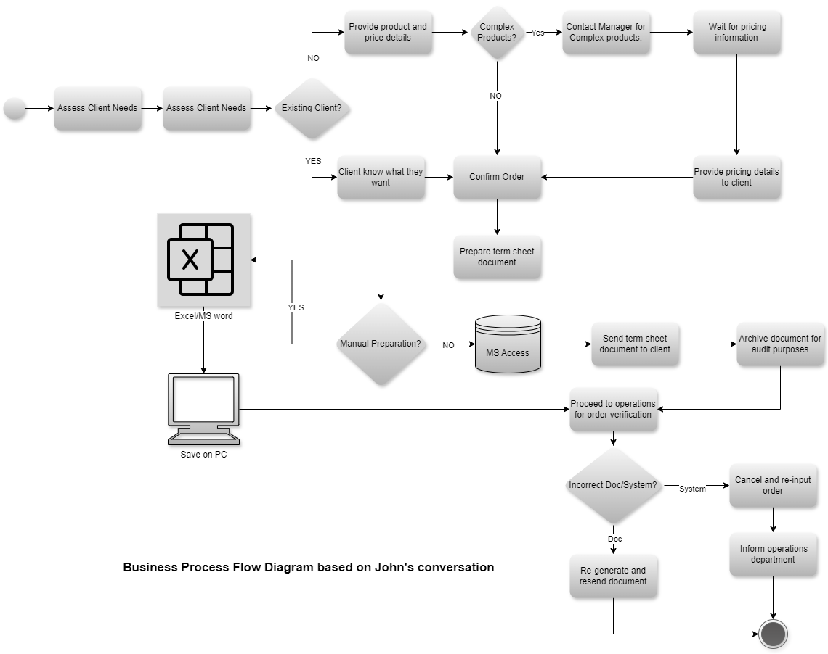

# Scenario 2: Enviro 365 Bank



**Steps for Identifying Stakeholder Analysis will be performed based on Importance and Influence towards a system:**

1. **Identify Key Stakeholders:**
   * Start by brainstorming and listing all potential stakeholders who might be affected by or have an impact on the new online banking system. This could include:
     + Internal stakeholders: Executives, managers, IT department, customer service representatives, marketing team.
     + External stakeholders: Customers, regulatory bodies, investors, technology partners, vendors, third-party service providers.
2. **Categorize Stakeholders:**
   * Group stakeholders into categories based on their level of influence, interest, or involvement in the project.
   * Use tools like a stakeholder matrix or power-interest grid to visually represent stakeholders based on their level of power and interest.
3. **Prioritize Stakeholders:**
   * Assess the importance of each stakeholder by considering factors such as:
     + Influence: How much power does the stakeholder have to impact the project?
     + Interest: How much does the stakeholder care about the project's outcome?
     + Dependency: To what extent does the project rely on the stakeholder's support or resources?
   * Rank stakeholders based on their priority level, with those having high influence and high interest typically being the most important.
4. **Gather Information:**
   * Conduct interviews, surveys, or focus groups with stakeholders to gather insights into their expectations, concerns, and requirements regarding the new online banking system.
   * Review existing documentation, such as business plans, regulatory guidelines, and market research reports, to understand stakeholder perspectives and industry standards.
5. **Assess Impact:**
   * Analyze the potential impact of the new online banking system on each stakeholder group.
   * Consider both positive and negative effects, such as increased efficiency, customer satisfaction, regulatory compliance, or potential resistance to change.
6. **Engagement Strategy:**
   * Develop a tailored communication and engagement strategy for each stakeholder group based on their priorities and preferences.
   * Determine the most appropriate channels and frequency of communication to keep stakeholders informed and engaged throughout the project lifecycle.
7. **Manage Relationships:**
   * Establish mechanisms for ongoing dialogue and feedback with stakeholders to address concerns and adapt to changing needs.
   * Identify opportunities to collaborate with key stakeholders to leverage their expertise and support for successful implementation.
8. **Review and Update:**
   * Regularly review and update the stakeholder analysis as the project progresses and new stakeholders emerge.
   * Adapt the engagement strategy and prioritize stakeholders based on evolving project requirements and stakeholder dynamics.

**Below are the examples of Stakeholder Analysis Table and Matrix**

High High

(high power, high influence)

* CEO (Internal)
* Regulatory Body (External)
* Investors (External)

(high Influence medium power)

* Head of IT Department (Internal)
* Government Agencies (External)
* Technology Partner (External)



(low influence, low power)

* Competitors (External).
* Customer Service Representatives (Internal)

(low influence, high power)

* Legal Department (Internal)
* Finance Department (Internal)
* Marketing Team (Internal)

Low

Power of Stakeholder High

**Stakeholder Analysis table**

|  |  |  |  |  |  |  |  |
| --- | --- | --- | --- | --- | --- | --- | --- |
| **Stakeholder Name** | **What is significant to the stakeholder?** | | **How could the stakeholder contribute to the project?** | **How could the stakeholder block the project?** | | **Strategy for engaging with the stakeholder?** | |
| * CEO (Internal) | | Project success as it reflects on overall organizational performance and strategic goals. | Provide financial resources, strategic direction, and executive support. | | Withdrawal of support, redirection of resources, or vetoing decisions. | | Provide regular updates on project milestones, demonstrate alignment with organizational objectives, and involve in key decision-making processes. |
| * Investors (External) | | Return on investment, growth potential, and risk management. | Provide financial resources, strategic guidance, and networking opportunities. | | Withholding funds, demanding changes in project direction, or withdrawing support. | | Provide regular updates on project progress, demonstrate value proposition and ROI. |
| * Technology Partner (External) | | Successful implementation of technology solutions, reputation enhancement, and business growth opportunities. | Offer expertise in system development, technical support, and integration services. | | Failure to deliver agreed-upon solutions, delays in implementation, or disputes over contractual terms. | | Establish clear communication channels, define project scope and deliverables, and monitor progress closely to address any issues promptly. |
| * Customer Service Representatives (Internal) | | Ensuring customer satisfaction, addressing customer inquiries and complaints, and maintaining a positive brand image. | Provide insights into customer needs, feedback on system usability, and assistance with user training and support documentation. | | Resistance to change if the new system complicates their workflow or negatively impacts customer experience, or if they perceive inadequacies in the system's design. | | Involve customer service representatives in user testing and feedback sessions, provide training on the new system, address concerns about system functionality. |
| * Legal Department (Internal) | | Ensuring legal compliance, risk mitigation, and protection of the organization from legal liabilities. | Provide legal expertise, review contracts and agreements, and ensure adherence to regulatory requirements. | | Identifying legal risks or issues that are not adequately addressed, refusing to approve contracts or agreements, or recommending against project implementation. | | Involve legal representatives in project planning and decision-making, seek early input on legal implications, and ensure clear communication regarding legal requirements. |
| * Head of IT Department (Internal) | | System reliability, security, and alignment with existing IT infrastructure. | Provide technical expertise, resource allocation, and infrastructure support. | | Non-alignment with IT standards, resource constraints, or technical objections. | | Involve in technical planning, address concerns about integration and security, and ensure alignment with IT strategy and goals. |

**Scenario 3: Enviro 365 Bank**

Enviro365 Investments Bank is seeking to automate the withdrawal process for its investors. The process currently makes use of manual forms which investors must download, complete, sign and send to the service area via e-mail. This is a time-consuming exercise which requires the service team to re-capture the withdrawal details on the line of business system and creates room for service team to make mistakes. When volumes are high, this also results in a bad experience for the investors where some of the withdrawals are processed late. With the new online process, investor experience will be improved, and time saved for the service area to focus on other important areas of the business.

Investors should be presented with a web interface that allows them to select a product they are withdrawing from; capture the withdrawal amount and banking details the money must be paid into. Once the withdrawal is completed, investors should receive a notification that shows them the balance before the withdrawal was made, the amount withdrawn and the closing balance. A copy of bank statement must be requested from investors when a withdrawal is submitted.

1. Create user experience requirement list for the above functionality.
2. Create a prototype (one screen of your choice) which forms part of the withdrawal process.

# Scenario 4: Enviro 365 Bank data definitions

|  |  |  |  |  |  |
| --- | --- | --- | --- | --- | --- |
|  | | | | |  |
| 1. **user experience requirement**      1. **Prototype:**      | | | | |  |
|  | **Entity name:** | **CUSTOMER** | | |
| **Attribute** | **Key (PK / FK)** | **Data type** | **Data size** |
| Customer ID | PK | INT | 10 |
| Create date (when the ‘Customer’ record was created) |  | DATETIME |  |
| Status (e.g. Good, Blacklisted) |  | VARCHAR | 25 |
| First name |  | VARCHAR | 50 |

|  |  |  |  |
| --- | --- | --- | --- |
| Last name |  | VARCHAR | 50 |
| Email |  | VARCHAR | 100 |
| Cell phone |  | VARCHAR | 15 |
| Date of birth |  | DATETIME |  |
| Address line 1 |  | VARCHAR | 100 |
| Zip code |  | VARCHAR | 100 |
| Gender (e.g. Female, Unknown) |  | VARCHAR | 20 |

|  |  |  |  |
| --- | --- | --- | --- |
| **Entity name:** | **ORDER** | | |
| **Attribute** | **Key (PK / FK)** | **Data type** | **Data size** |
| Order ID | PK | INT | 10 |
| Create date (when the cart record was created) |  | DATETIME |  |
| Status (e.g. Paid, Abandoned, Dispatched) |  | VARCHAR | 25 |
| Order date (when the cart was checked out and paid) |  | DATETIME |  |
| Customer ID | FK | INT | 10 |
| Total pre-tax value |  | DECIMAL |  |
| Total tax value |  | DECIMAL |  |
| Total order value |  | DECIMAL |  |
| Total quantity of products |  | INT | 10 |

**Scenario 5: Website Services Inc.**

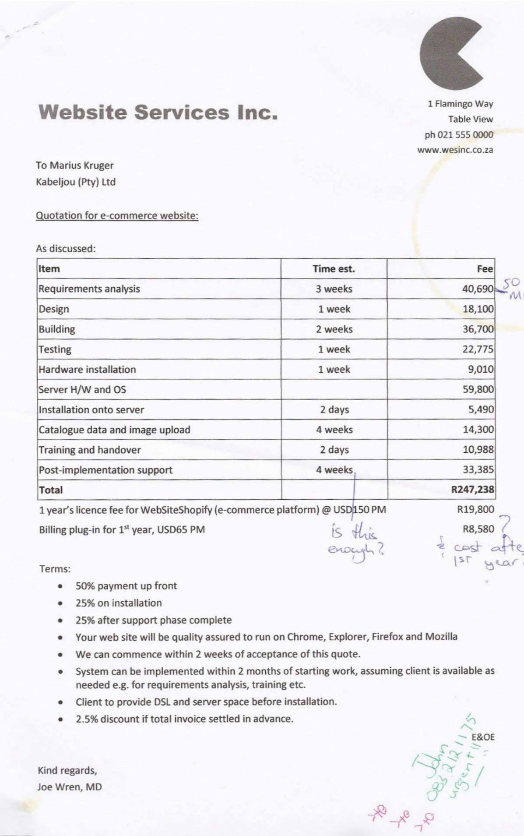

Explain your understanding of the business analyst’s role in each stage of the Software development life cycle using the Website Services Inc quotation.

Prepare a high-level project plan by referencing the Website Services Inc quotation.

1. **Business Analyst's Role in Each Stage of the Software Development Life Cycle (SDLC) using the Website Services Inc Quotation**:

**Requirement Analysis**

* Business Analyst's Role: Gather and analyze business requirements for the e-commerce website.
* Responsibilities: Liaise with stakeholders to understand their needs, document requirements, and ensure alignment with business goals. Translate business requirements into technical specifications for development.
* Challenges: Ensuring all stakeholder needs are captured accurately and prioritized appropriately. Balancing conflicting requirements and constraints.

**Design:**

* Business Analyst's Role: Collaborate with designers and developers to create a user-friendly and visually appealing website design.
* Responsibilities: Translate functional requirements into design specifications. Ensure designs meet usability and accessibility standards. Conduct user research and usability testing.
* Challenges: Ensuring the design aligns with both business requirements and technical constraints. Addressing any discrepancies or conflicts between design and functionality.

**Building:**

* Business Analyst's Role: Work closely with developers to ensure the implementation of features aligns with business needs and design specifications.
* Responsibilities: Clarify requirements, provide ongoing clarification and guidance to developers, and participate in sprint planning and reviews. Conduct user acceptance testing (UAT) to validate implemented features.
* Challenges: Managing changing requirements and scope creep. Ensuring effective communication between business stakeholders and development team.

**Testing:**

* Business Analyst's Role: Lead the testing phase to ensure the website meets quality standards and functional requirements.
* Responsibilities: Develop test plans, coordinate testing activities, and analyze test results. Identify and prioritize defects for resolution. Ensure the website is compatible with various browsers.
* Challenges: Identifying and resolving defects in a timely manner. Ensuring comprehensive test coverage across all features and functionalities.

**Deployment and Support:**

* Business Analyst's Role: Support the deployment of the website onto the server and provide ongoing support post-implementation.
* Responsibilities: Coordinate deployment activities, monitor system performance, and address any post-implementation issues. Provide training and handover to users. Collect feedback for future improvements.
* Challenges: Managing user expectations and addressing any technical issues that arise post-implementation. Ensuring smooth transition to the support phase.

1. **Project plan (tasks) for each SDCL Website Services Inc quotation and Gantt Chart.**

Requirement Analysis (3 weeks)

* Gather and document business requirements.
* Conduct stakeholder meetings and interviews.
* Define project scope and objectives.
* Deliverable: Requirements documentation.

Design (1 week)

* Collaborate with designers to create website wireframes and mockups.
* Ensure design aligns with business requirements and usability standards.
* Conduct user testing and gather feedback.
* Deliverable: Design specifications.

Building (2 weeks)

* Work with developers to implement website features and functionalities.
* Conduct regular reviews and provide feedback to ensure alignment with requirements.
* Perform user acceptance testing (UAT) to validate implemented features.
* Deliverable: Implemented website features.

Testing (1 week)

* Develop and execute test plans to ensure website functionality and quality.
* Identify and prioritize defects for resolution.
* Conduct compatibility testing across different browsers.
* Deliverable: Test reports and resolved defects.

Deployment and Support (4 weeks)

* Deploy website onto the server and configure hardware and software components.
* Provide training to users and handover documentation.
* Monitor website performance and address any post-implementation issues.
* Provide ongoing support during the post-implementation phase.
* Deliverable: Deployed and supported website

Gantt Chart Illustration

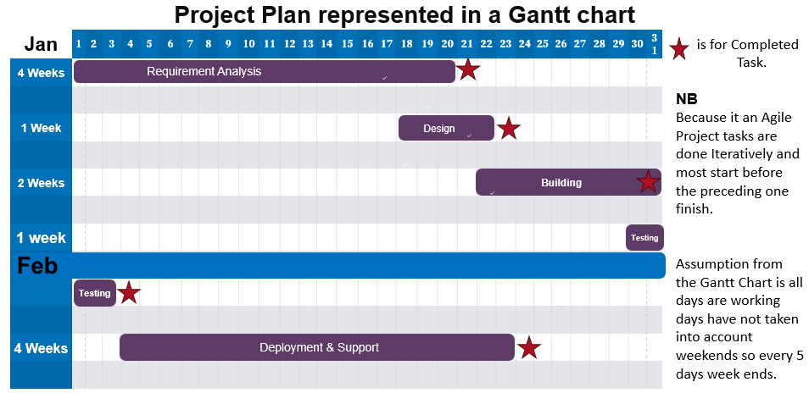

The adequacy of a 4-week post-implementation support period depends on various factors, including the complexity of the project, the size of the team providing support, the level of preparation and training provided to users, and the potential issues expected during the initial rollout of the system.